|  |
| --- |
| neuroSHARE |
| Virtual Caseload Display with no Age of Onset |

|  |
| --- |
| Technical Specifications – Rev 1.0 |
| 7/25/2018 | |
|  |

Table of Contents

Scope of Work 3

Virtual Caseload Display – Do Not Display if Age of Onset is Blank 4

Virtual Caseload – Blank Age of Onset Messaging 5

Scope of Work

Clinicians can load a reference cohort to compare EDSS trends and use this to help with conversations about adherence and treatment decision making. The purpose of the reference population is to allow clinicians to see compiled data on disease course for a larger number of individuals with MS.

The data from the reference cohort is heavily dependent on the patient’s disease duration. The disease duration is calculated by the patient’s “Age of Onset”, which is a field that clinicians can complete in the neuroSHARE app. If the “Age of Onset” field is blank then no reference cohort data should display on the graph and an error message should display. This is to prevent potentially inaccurate data from being displayed. The error message should tell the user that the reference cohort cannot be displayed because the Age of Onset field is blank and prompt the user to complete the field.

The primary areas of development are:

**Virtual Caseload Display**

* Update display logic to check whether or not the “Age of Onset” field is blank -> if blank, then do not display any virtual caseload data.

**Virtual Caseload Messaging**

* Display new error message if the “Age of Onset” field is blank.

Virtual Caseload Display – Do Not Display if Age of Onset is Blank

The data from the reference cohort is heavily dependent on the patient’s disease duration. The disease duration is calculated by the patient’s “Age of Onset”, which is a field that clinicians can complete in the neuroSHARE app. If the “Age of Onset” field is blank then no reference cohort data should display on the graph. This is to prevent potentially inaccurate data from being displayed.

Mockup

| Item | Data Sources / APIs | Behavior / Logic / Notification Rules |
| --- | --- | --- |
| Virtual Caseload Display Logic |  | Update virtual caseload display logic to include:   * Check whether or not the “Age of Onset” field is blank.   + If blank, do not display any virtual caseload data.   + If not blank, use value and continue with current logic. |

Virtual Caseload – Blank Age of Onset Messaging

If the “Age of Onset” field is blank then there should be an error message telling the user that the reference cohort cannot be displayed because the Age of Onset field is blank and prompt the user to complete the Age of Onset field in order to see the reference cohort.

Mockup

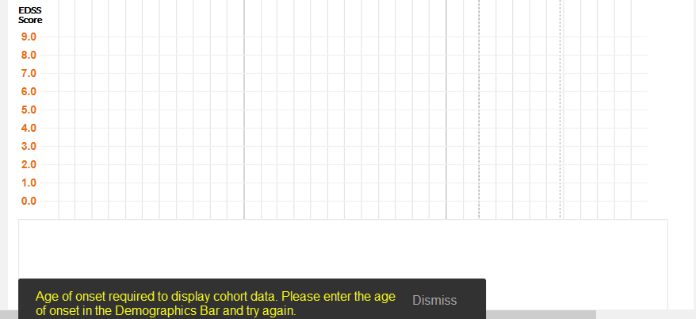

| Item | Data Sources / APIs | Behavior / Logic / Notification Rules |
| --- | --- | --- |
| Error Message |  | Create new error message:   * Text: “Age of onset required to display cohort data. Please enter the age of onset in the Demographics Bar and try again.” |
| Error Message Logic |  | Update virtual caseload logic to include:   * Display error message when age on onset field is blank. |